* **Introduction**

**FettleUp**

When we feel sick, we need to go to hospital and take an appointment with doctor. The severity of the disease is less this will be a time taking process in our day-to-day busy life. In this smart world, we thought of having one application that will be handy to opt for a doctor and make an appointment with him in online and discuss regarding our problem and get the necessary suggestions from him, so we can save our time. Finally, we came up with this thought to save time for everyone.

* **Project Goal and Objectives (Revised)**

**Overall Goal:**

The main goal of this application system is to provide an end-to-end communication between the common people and their consultation doctors. The gap between them is filled by using various resources of communication such as online chat, request for appointment consultation and ease of search in nearby emergency.

**Specific Objectives:**

Technology is evolving everyday, so creating an interactive web application by reaching our goal within the time frame is our major objective. The key thing of the application is to provide end-to-end relationship between doctor and patient. We personally take care in building a real time system that is user friendly and reachable to patients round the clock. To make a system, which feeds instant guidelines to people, regarding their appointment status, doctor availability and other related information.

**Specific Features:**

The features are classified as

• Make a hassle free appointment and consultations with doctor,

• Round the clock advice from doctors by using the chat option,

• Provide daily diet for future reference to doctor’s in case of health checkup,

• View prescription and shop for them on e-commerce sites i.e. Wal-Mart pharmacy,

• Look for nearby emergency and pharmacy with single click,

• Feedback option on their experience.

**Significance:**

As we can see there are many applications for health care but our application is stand out from others. In this application we can quickly check for the availability of doctor in particular categories and schedule an appointment with him or else we can chat with him from our desk itself, which is time saving process. Therefore, this application will become the dominant form of interaction.

* **Project Plan**

**Zen-Hub Screenshot:**

For the first increment we had issues regarding the working of Login and Register pages, validation through local storage, integrating Facebook and Google login API and writing unit test cases.

**Project Timeline, Members and Task Responsibility**

The issues that are registered and current one’s which we are working are updated and can be viewed in github repository. The below screenshot will show you the issues and their respective categorization’s i.e. New issues, Icebox, Backlog, In-Progress.

**Burn-Down Chart:**

Burn-Down chart is created for the above issues via Milestones in github. Below is the screenshot for more information,

* **First Increment Report**

**Existing Services/REST API**

**API’s Used**

**Facebook API:**

We have integrated Facebook API for our login module using OAuth 2.0 security.

**Google API:**

We also included Google API in our login module using OAuth 2.0 so users can easily login into our web application by using their respective existing accounts.

**Bootstrap:**

Bootstrap 4.0 is used in creating the web pages and has a major role in designing the CSS elements and layouts.

**API’s Forthcoming:**

* Google Maps API
* Practo API
* Speech to Text API
* Mail service API

**Detail Design of Features (using tools)**

**Wireframes**

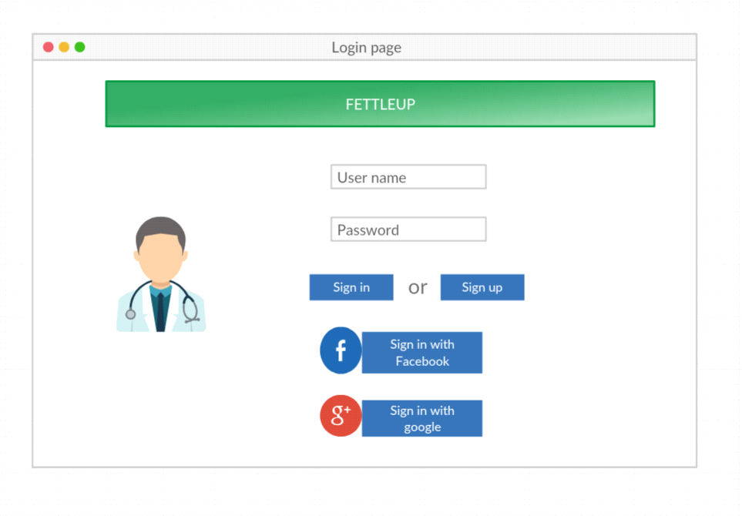

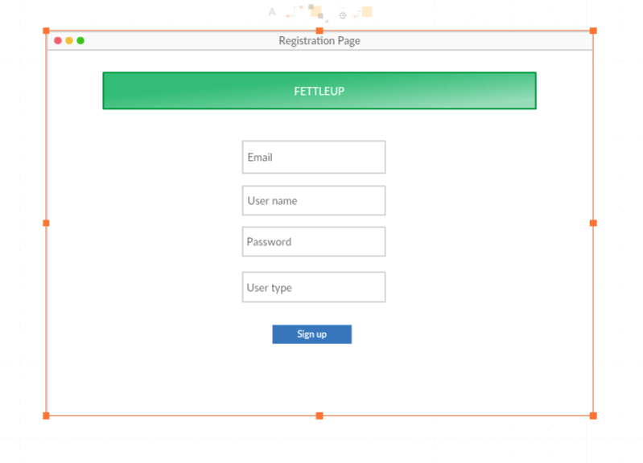

**Class Diagram**

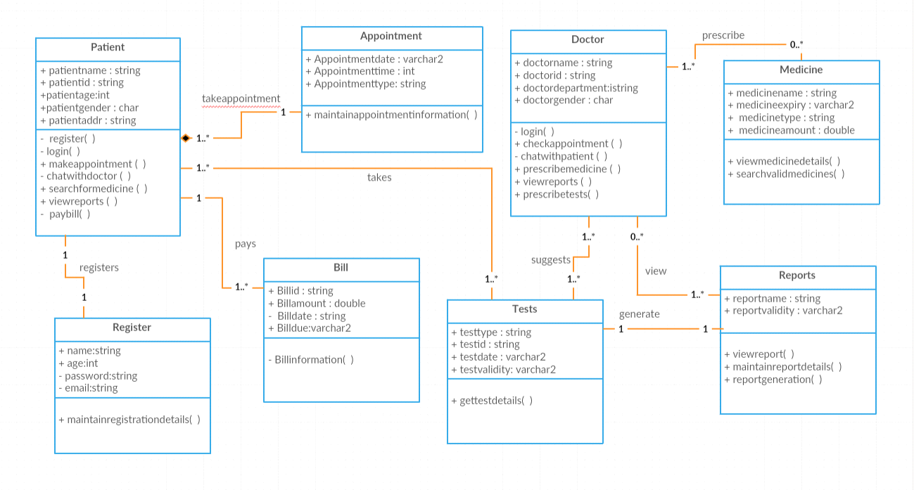

**Usecase Diagram**

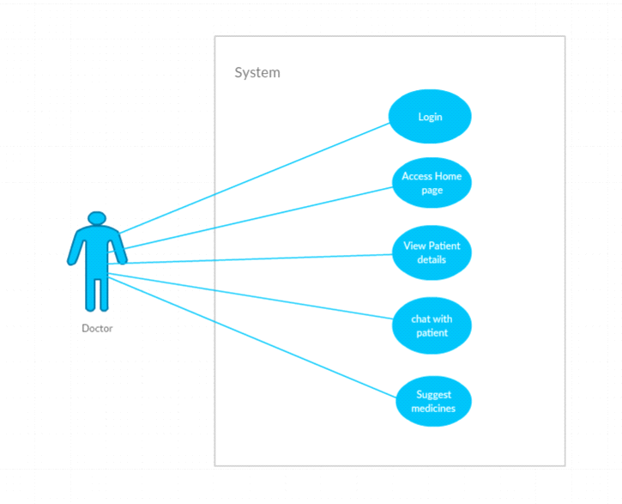

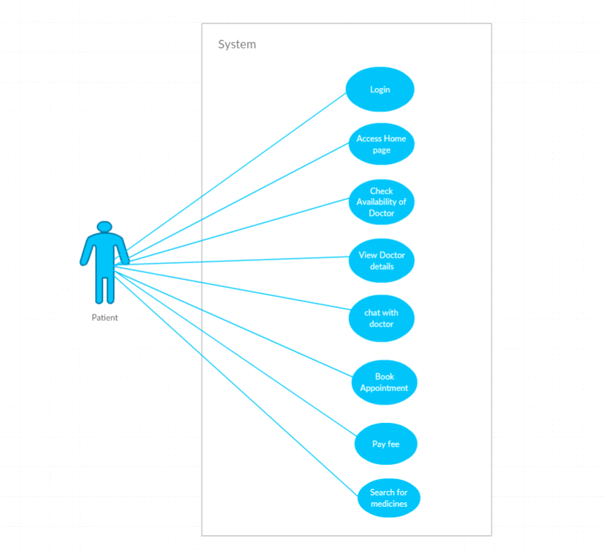

**Sequence Diagram**

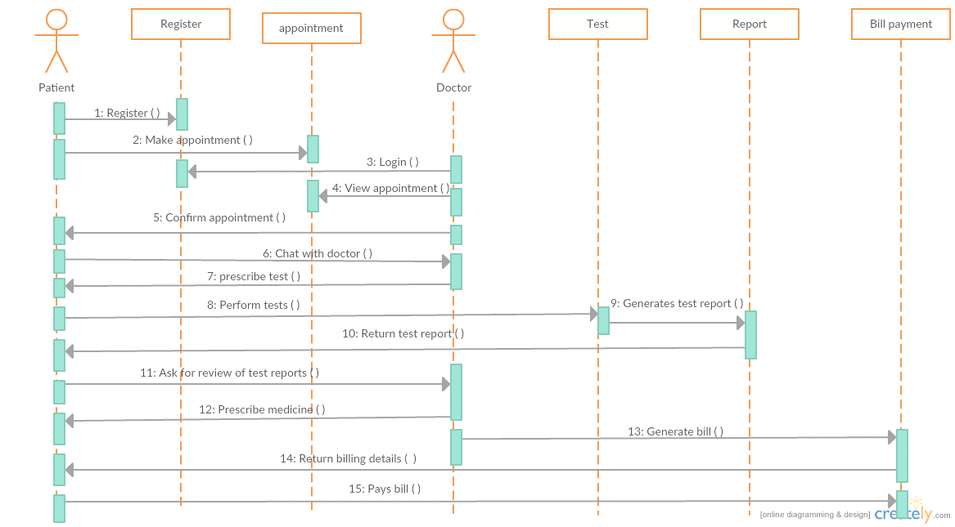

**Architecture Diagram**

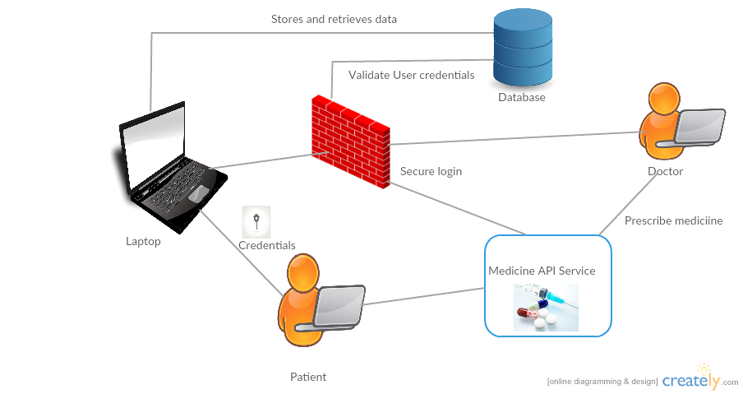

**Screenshots:**

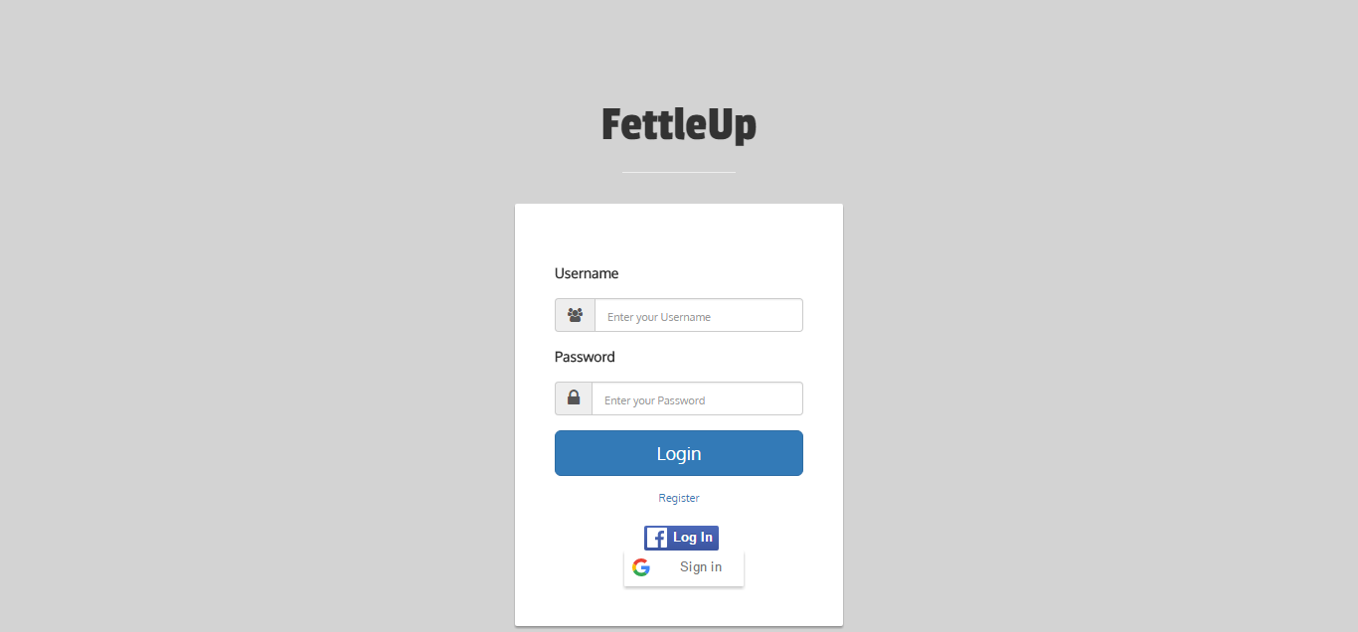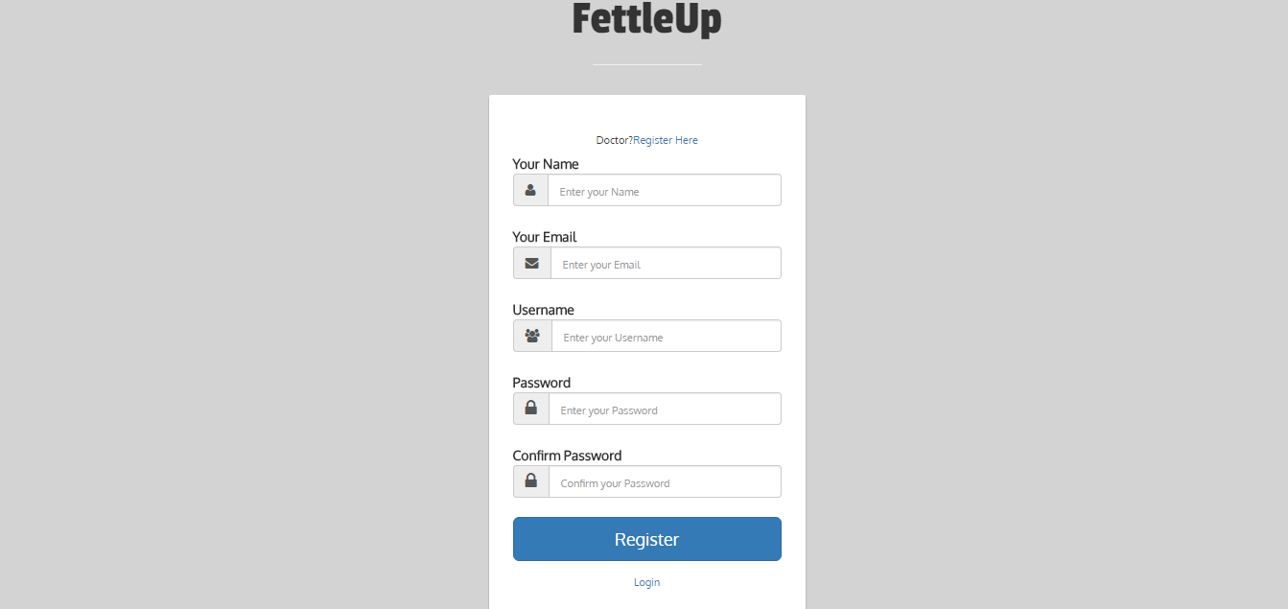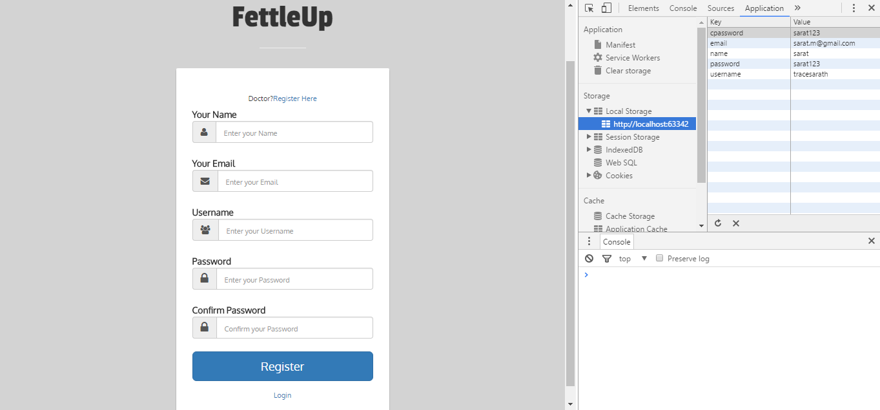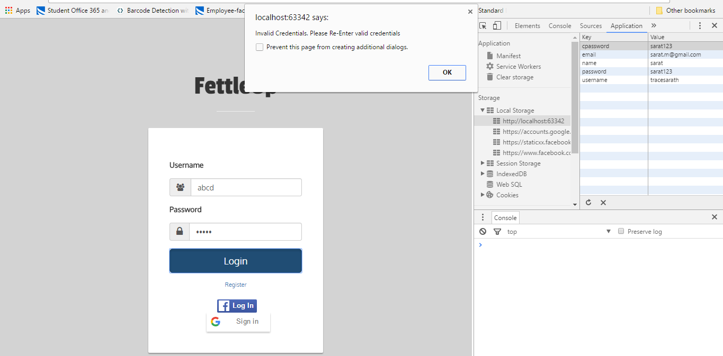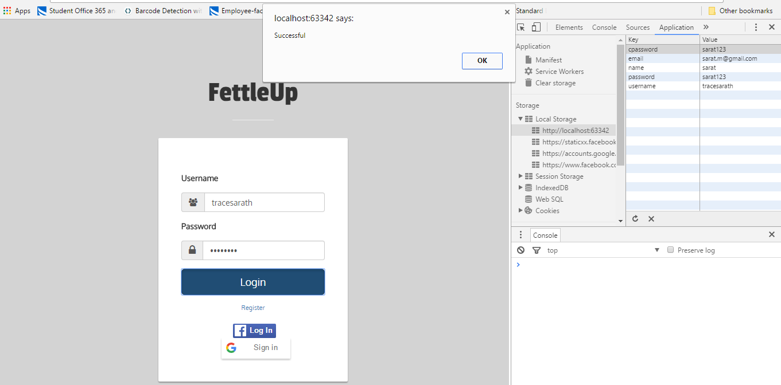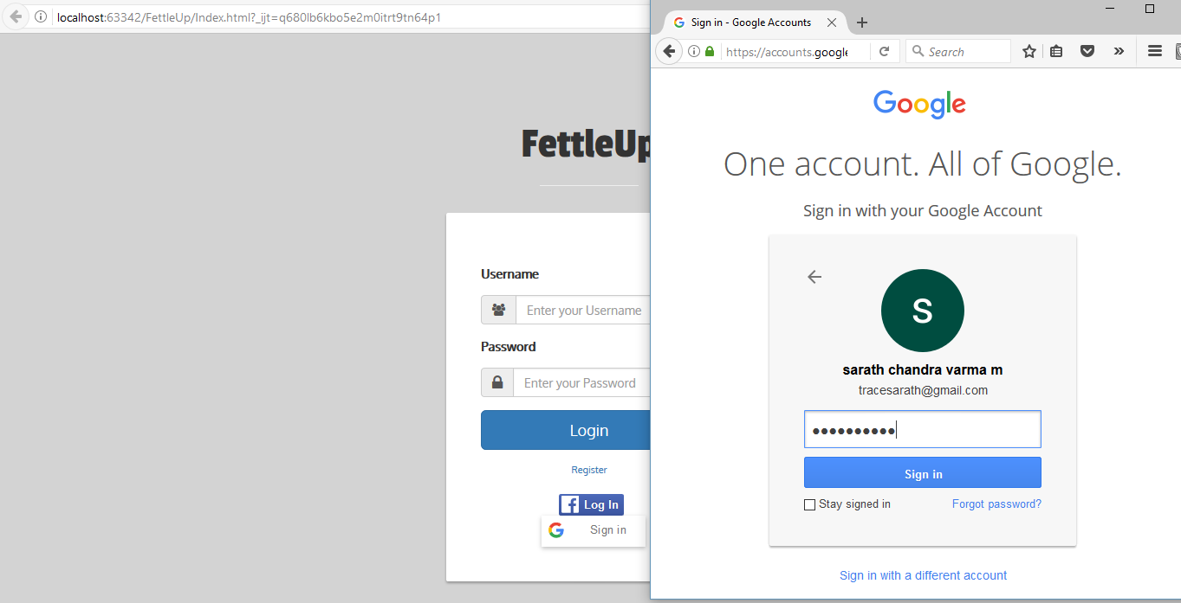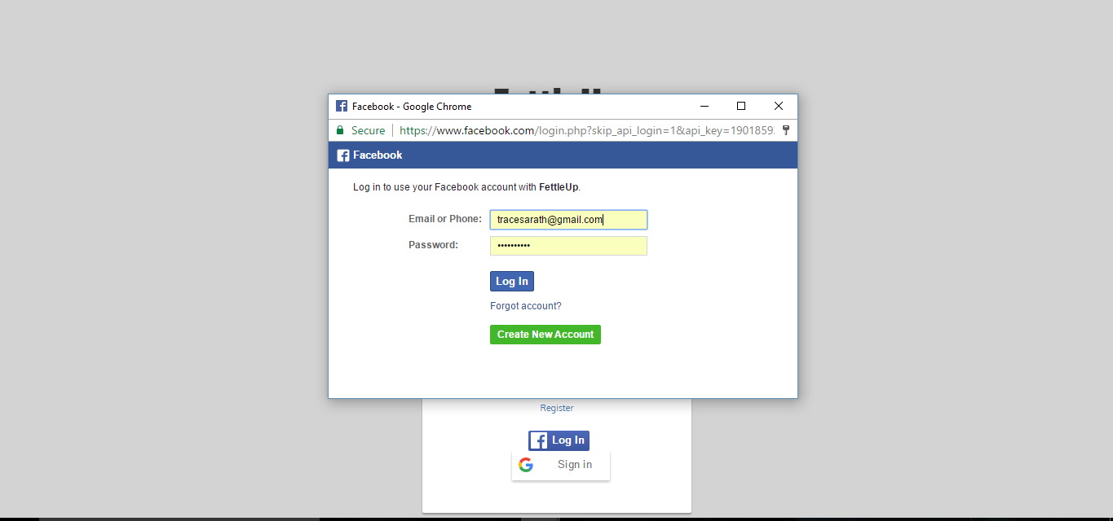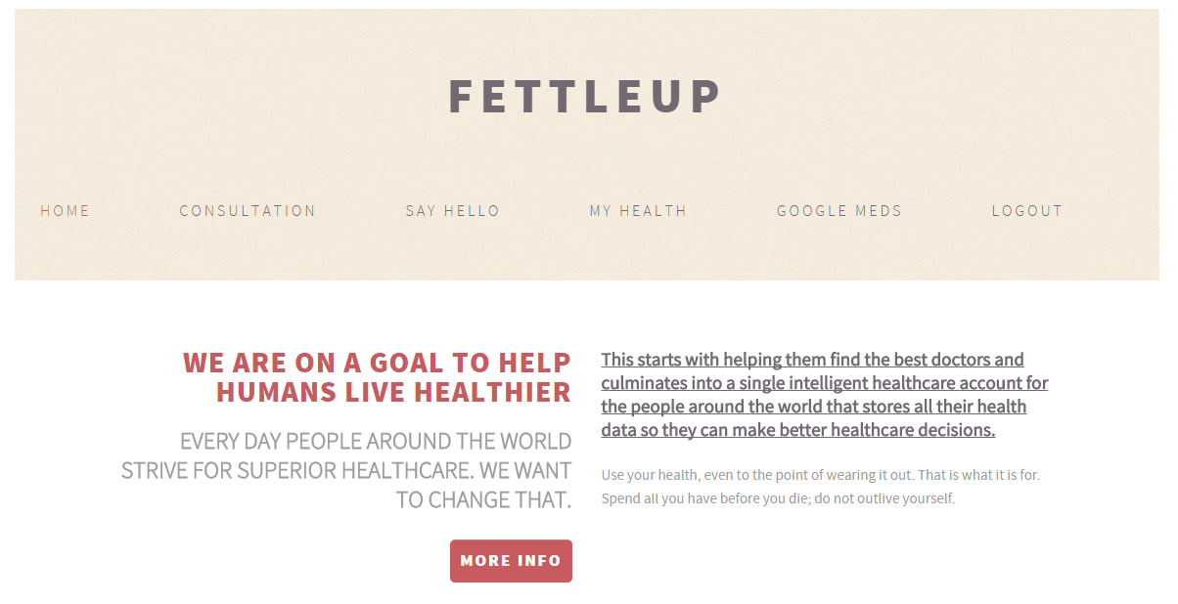

**User Stories**

|  |  |  |
| --- | --- | --- |
| **As a** | **I want to** | **So that** |
| User | Book an appointment for consultation | I can discuss my condition with the doctor. |
|  | Chat with the designated person | I can able to get the help during emergency. |
|  | Search for a nearby pharmacy store | I’ll be able to reach them without hurry. |
|  | Upload my documents in the website | My doctor can view health condition and other general information. |
|  | Search for a nearby doctor | I’ll be able to reach him quickly in an emergency situation. |

**Unit Testing**

**Test cases for Login and Sign Up Pages**

|  |  |  |  |  |
| --- | --- | --- | --- | --- |
| **Case** | **Test Case Description** | **Expected Result** | **Actual Result** | **Result** |
| Login | Invalid Username and Invalid Password | Error Message should pop up, stating that invalid credentials and Re-enter valid credentials. | Error Message should pop up, stating that invalid credentials and Re-enter valid credentials. | Pass |
| Login | Invalid Username and Valid Password | Error Message should pop up, stating that invalid credentials and Re-enter valid credentials. | Error Message should pop up, stating that invalid credentials and Re-enter valid credentials. | Pass |
| Login | Valid Username and Invalid Password | Error Message should pop up, stating that invalid credentials and Re-enter valid credentials. | Error Message should pop up, stating that invalid credentials and Re-enter valid credentials. | Pass |
| Login | Valid Username and Valid Password | Re-direct to Home Page. | Re-direct to Home Page. | Pass |
| Signup | Must satisfy email ID format | Error Message is please enter a valid email ID. | Error Message is please enter a valid email ID. | Pass |
| Signup | Satisfy password length to be greater than 8 | Error Message is please enter a valid password. | Error Message is please enter a valid password. | Pass |
| Signup | Password and confirm password fields must | Error Message is passwords are not same. | Error Message is passwords are not same. | Pass |

* **Implementation and Deployment**

We have implemented our web application using the mentioned API’s and modules. The process flow of the application can be viewed in the below screenshots,

**Github Wiki Page**

The github wiki page URL for the screenshots and the process flow is updated in the following link

* **Project Management**

**Implementation Status Report**

**Technologies Used**

We have collaborated various technologies in the development of the project and in building the application. Some of them are,

* HTML5
* CSS3
* Angular JS
* JavaScript

**Work Completed**

The completed tasks in this increment are,

* Design and implementation of Login and Register Pages,
* Design and base layout of the Home Page,
* Architecture and flow of the application is defined,
* API’s are successfully integrated in the application.

**Work to be Completed**

The work to be completed for next increment is,

* Adding the layout and designing for remaining pages,
* Navigation through hyper links,
* Integration of other Restful API’s,
* Minor changes to user interface.

**Contributors**

* Saketh Garuda- **25%**
* Mudunuri Sri Sai Sarat Chandra Varma- **25%**
* Yalamanchili Sowmya- **25%**
* Nandanamudi Sreelakshmi- **25%**
* **Bibliography**
* [www.creately.com](http://www.creately.com/)
* [www.bootstrap.com](http://www.bootstrap.com/)
* [www.bootsnipp.com](http://www.bootsnipp.com/)
* [www.angularjs.org](http://www.angularjs.org/)
* [www.developers.facebook.com](http://www.developers.facebook.com/)
* [www.console.developers.google.com](http://www.console.developers.google.com/)